Robert Dennis

Linux Admin

12/5/2019

Ciosfy is a very unique command that you can run once you have it install. This will break down every aspect of your server. Things I noticed about my server that I would change after running this is keeping it up to date, cisofy will tell you exactly how many months you are behind in updates. It is important to I keep your servers and systems up to date so that you are less vulnerable to attacks and security flaws.

Closing more ports will be something I should do to keep me safe from hackermans. Keeping my system up to date is huge as well. One thing that would be nice of cisofy would be a short summary at the end to give you tips on what you could do to make your server more secure. Maybe a premium version could be made to make this happen?

HEALTH CHECKING MY SERVER

SCRIPT FOR ASSIGNMENT:

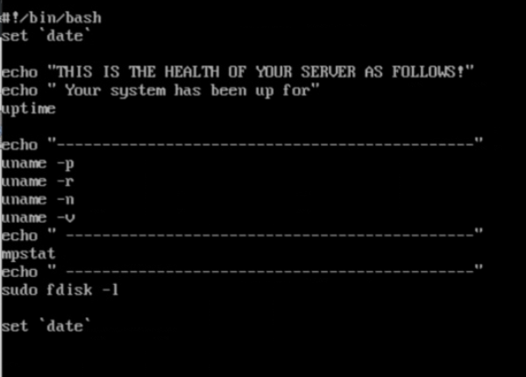

Output:

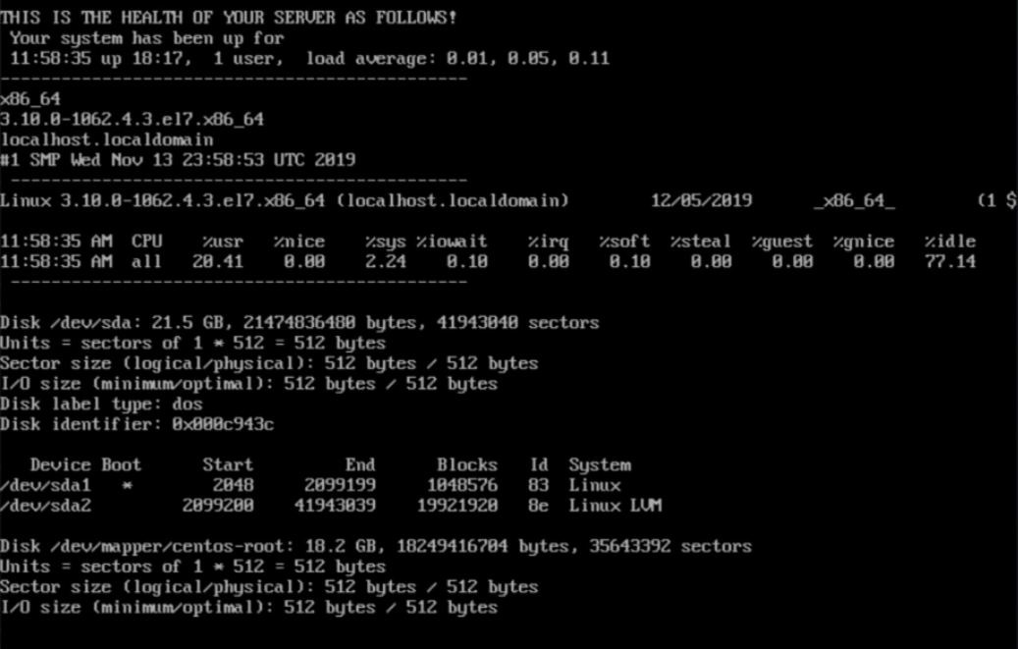

Appended date for output: 